**App development overview**

Developing an app for Android requires a few basic steps. Using the tools and technologies in this course, we will first start with a project. Think of a project as a container. Inside of that container are files, assets and settings that are all the pieces that are used together to create your app. Your project has a few basic components that are inside. You have the settings for the project. These are the settings that define how the app works, what are requires of the device, how it should look in Google Play, and other things like the app icon, version number and more.

You have the assets of the project. For instance, you might have an app that has a sound effect for notification or an action that takes place. That sound file is part of the assets of the project. You have the layout and design of the app. This is a collection of files that lay out the screens for your app. For instance, test boxes, buttons, scrollable areas, menus, and where they appear on the screen, are all part of the layout component of your project. You have the behavior of the app. This is the code where you tell the app what to do and how the user can work with the app.

So if the app needs to access data, files in the device, respond to a button press by the user, or process information, this is one of the key areas. For all these earlier four areas, you, as the developer, are able to define all of them. The fifth area is a key component of the project, but you don't build it. It's called the SDK or framework. This critical component is all the software that Google, and others, have provided to allow your app to work on Android, access system resources, render things on the screen, and pretty much make everything work the way you want to.

Without this, you have tons of code and assets, but there's no way for Android to understand and work with your instructions. When you have all five of these in your project, you're able to use them to build your app. To do this, your computer needs to analyze all the things you have in your project, and find a way to convert it to natively work with the device. This is called compiling, or building the app. The compiler, or build engine, takes the five components to your project and converts them into a format that the device can run. This is the app or application.

When you have the app, you can install on your own device but you need to find a way for others to download it as well. When you have the finished app, you then need to upload it and submit it to Google Play to allow others to find it, purchase it, or charge for it, and download it to use on their own devices. When you upload your app, Google will analyze and make sure that it doesn't do anything that could be harmful and then list it in Google Play. If you make updates to your app, like add new features or fix a bug, you would modify one or more of the primary components of the project, rebuild and upload the changes to Google, to update the version that is listed in the Store.

This is the essential process for how app development works. So from the five components of the app, to compiling and distributing to Google Play, this is the basic process you will take when you build your app for Android.

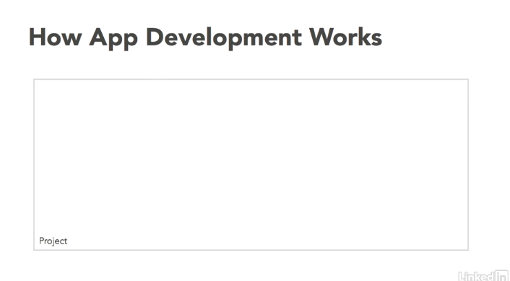

Figure: Think of a project as a container

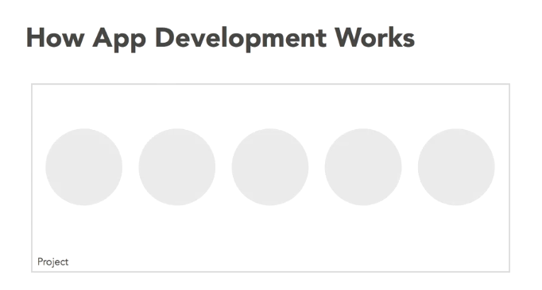

Figure: A project has a few basic components that are inside

